# DATA ANALYSIS PROJECT: SALES ANALYSIS USING POWER BI

Embarking on my first data analysis project, I utilized Power BI to analyze and visualize a sales dataset. This journey has been enlightening and has deepened my understanding of data-driven decision-making.

## About the Dataset

The dataset includes sales, order info, customer data, and shipping details. Originally intended for Pentaho DI Kettle, it was perfect for sales simulation training, segmentation, customer analytics, and clustering.

## Problem Statement

Retail businesses must understand customer behavior and product trends to optimize operations and enhance satisfaction. This project aims to answer the following key questions:

1. What is the number of sales over the past several years?
2. Which month has the most sales?
3. Which country has the most sales?
4. What types of products are ordered the most?
5. What are the top 5 best-selling products?

## Data Cleaning & Transformation

I used Power BI to clean and transform the data. This process involved organizing disorganized data into a 'tidy' format suitable for analysis.

## Analysis Results

**Table 1:** Product based analysis.

1. **Sales Trends:** Total sales amounted to $9.46M, with a 13% increase from the previous period.
2. **Product Categories:** Technology led in sales ($3.54M), followed by Furniture ($3.09M) and Office Supplies ($2.83M).
3. **Top Products:** The top 10 sub-categories by profit include Copiers, Phones, and Chairs.

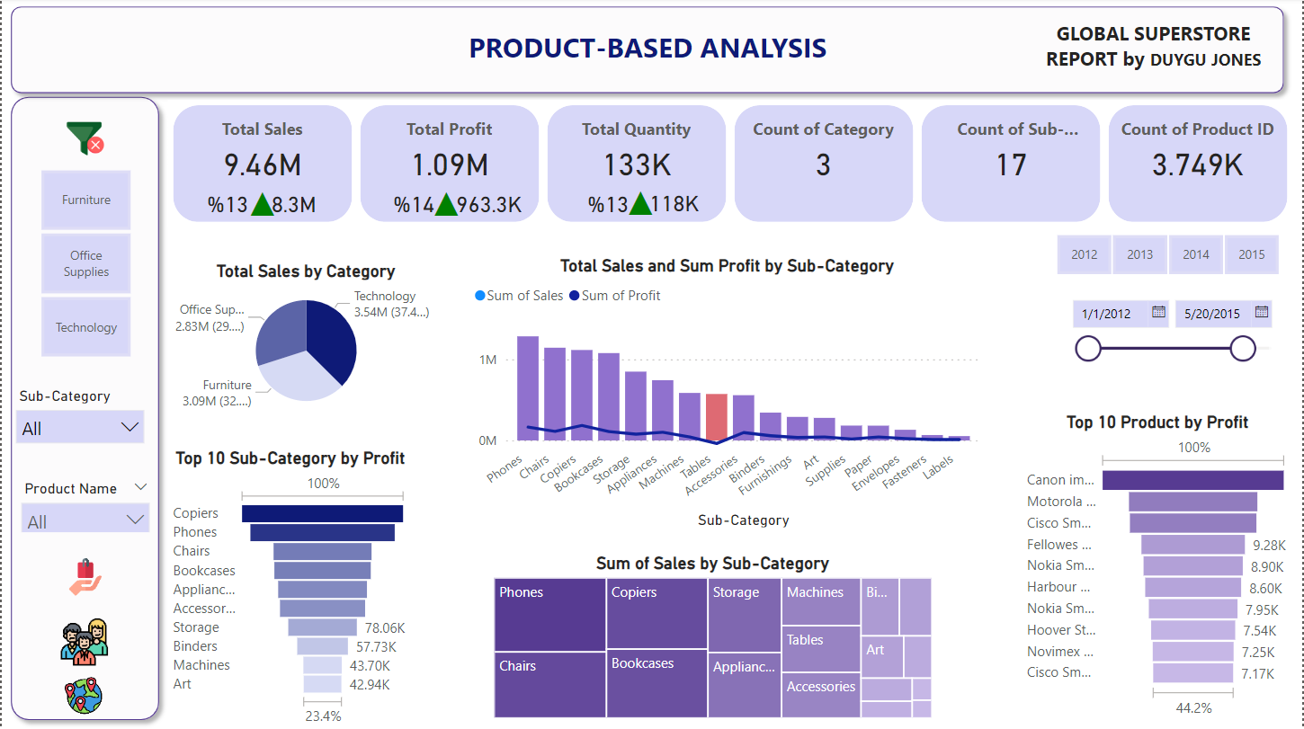

**Table 2: Customer Insights:** Total sales reached $12.64M, with the Consumer segment leading in sales (51.48%).

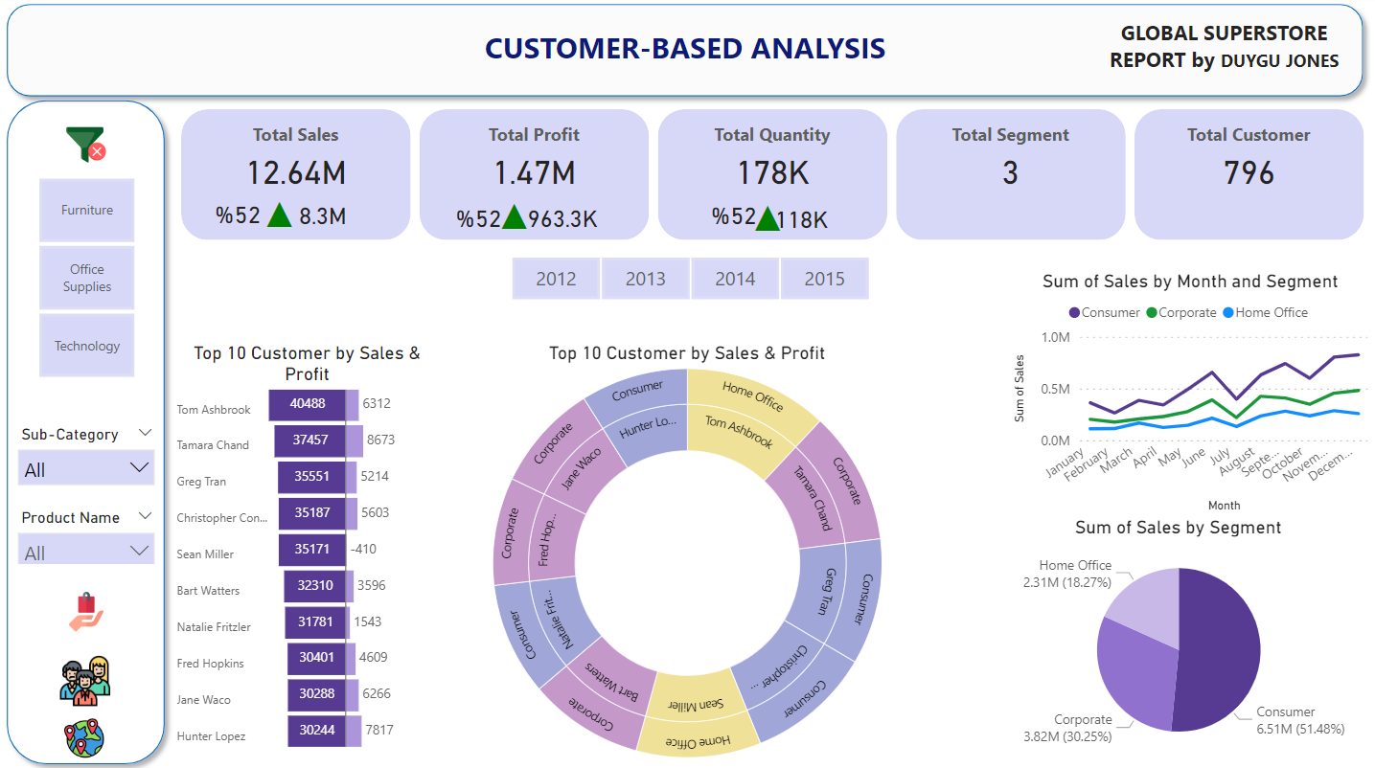

**Table 3: Geographical Distribution:** Sales were highest in Western Europe, followed by Central America and Oceania.

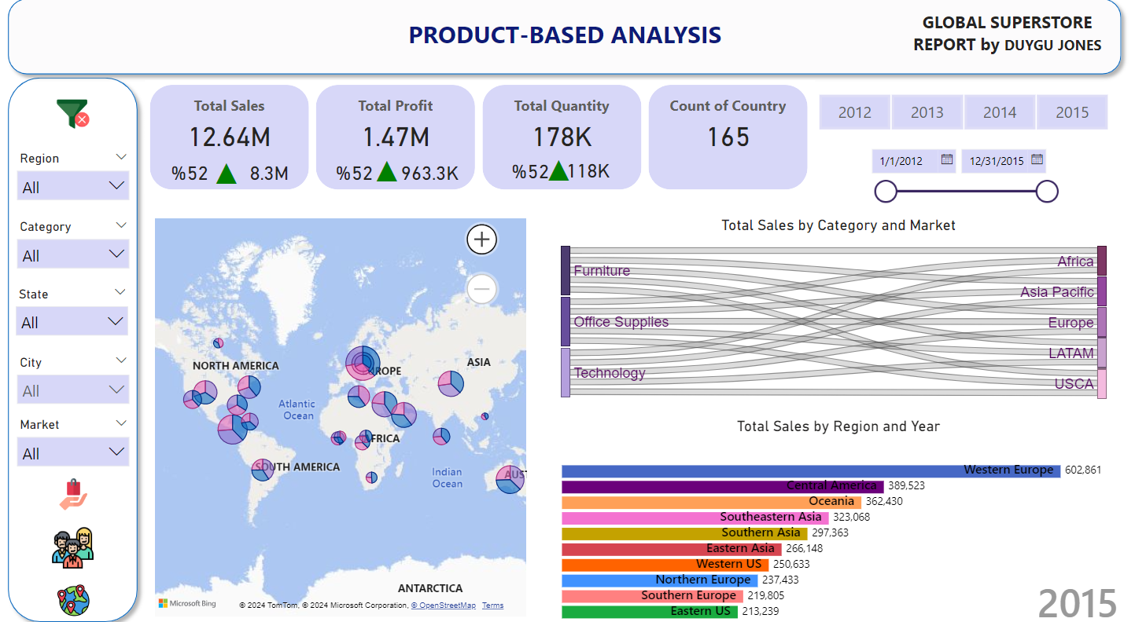

## Recommendations

1. **Sales Trend Analysis:** Regular analysis of sales trends over multiple years can help understand long-term changes and their influencing factors.
2. **Monthly Sales Insights:** Identifying peak sales months can aid in planning targeted promotions and marketing activities.
3. **Focus on High-Sales Regions:** Tailoring marketing strategies to high-sales regions can enhance sales effectiveness.
4. **Product Improvement:** Insights on popular products can guide product development and improvement efforts.
5. **Leverage Best-Sellers:** Focusing on best-selling products can optimize marketing and development resources.

This project has been a valuable learning experience. I look forward to receiving feedback and continuing to develop my data analysis skills.

References:

….

**Improved Areas Using Specific Fields and Visualizations**

1. **Data Granularity**
   * **Fields**: Date, Sales Amount
   * **Visualization**: Line chart with a weekly or daily breakdown.
   * **Insights**: Identify short-term trends, seasonal spikes, or dips in sales.
2. **Customer Segmentation**
   * **Fields**: Customer ID, Age, Gender, Purchase Frequency, Total Spend
   * **Visualization**: Clustered bar chart or segmentation tree map.
   * **Insights**: Understand different customer segments and their purchasing behaviors.
3. **Predictive Analytics**
   * **Fields**: Historical Sales, Marketing Spend, Economic Indicators
   * **Visualization**: Forecasting line chart.
   * **Insights**: Predict future sales trends and prepare for upcoming demand changes.
4. **Interactive Features**
   * **Fields**: Category, Sub-category, Region, Time Period
   * **Visualization**: Interactive dashboard with filters and drill-down capabilities.
   * **Insights**: Allows users to explore data dynamically based on their needs.
5. **Comparative Analysis**
   * **Fields**: Competitor Sales Data, Market Share, Industry Benchmarks
   * **Visualization**: Side-by-side bar charts or spider charts.
   * **Insights**: Compare performance against competitors and industry standards.

**Example Visualizations and Insights**

1. **Daily Sales Line Chart**
   * **Insights**: Spot daily sales patterns, identify high sales days, and investigate anomalies.
2. **Customer Segmentation Tree Map**
   * **Insights**: Visualize which customer segments contribute most to sales and profits, and tailor marketing strategies accordingly.
3. **Forecasting Line Chart**
   * **Insights**: Predict future sales trends, helping in inventory management and marketing planning.
4. **Interactive Dashboard**
   * **Insights**: Users can interact with data, exploring various dimensions like time, region, and product categories to derive specific insights.
5. **Competitor Comparison Bar Chart**
   * **Insights**: Benchmark performance against competitors to identify strengths and areas for improvement.

By using these fields and visualizations, the analysis becomes more detailed, actionable, and insightful for stakeholders.